**Project Design Phase-II**

**Data Flow Diagram & User Stories**

|  |  |
| --- | --- |
| Date | 31 January 2025 |
| Team ID | LTVIP2025TMID35138 |
| Project Name | Citizen AI – Intelligent Citizen Engagement Platform |
| Maximum Marks | 4 Marks |

**📊 Data Flow Diagram (DFD) Guidance for CitizenAI**

**🔄 Level-0 DFD (Context Diagram)**

**Entities:**

* User (Mobile/Web)
* Admin
* Customer Support

**System: CitizenAI**

**Major Data Flows:**

* User inputs (registration, queries)
* AI response (scheme recommendation)
* Admin reports
* Support communication

**📘 Level-1 DFD (Detailed Breakdown)**

**Processes:**

1. User Registration/Login
2. Query Processing via AI
3. Personalized Scheme Recommendation
4. Dashboard & Visualization
5. User/Query Management (Admin Panel)

**Data Stores:**

* User Profile DB
* Scheme DB
* Feedback & Query Logs

**External Entities:**

* Government API (for schemes)
* Email Service (for confirmation)

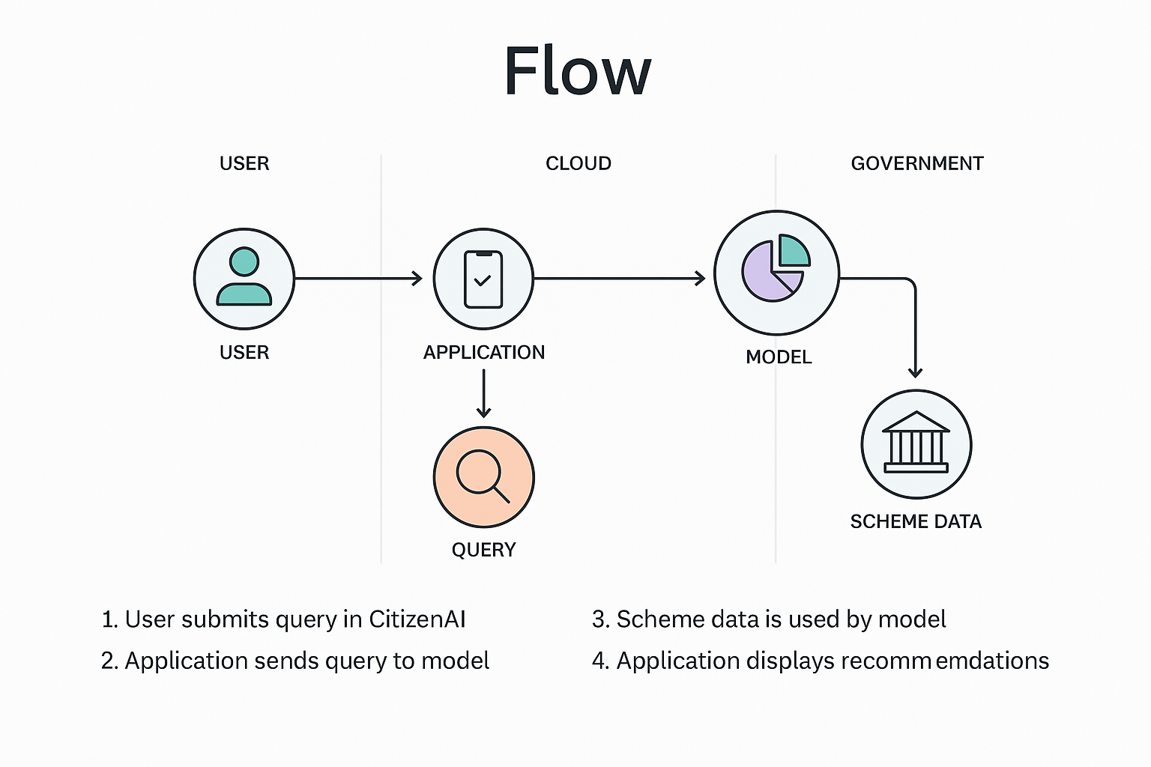

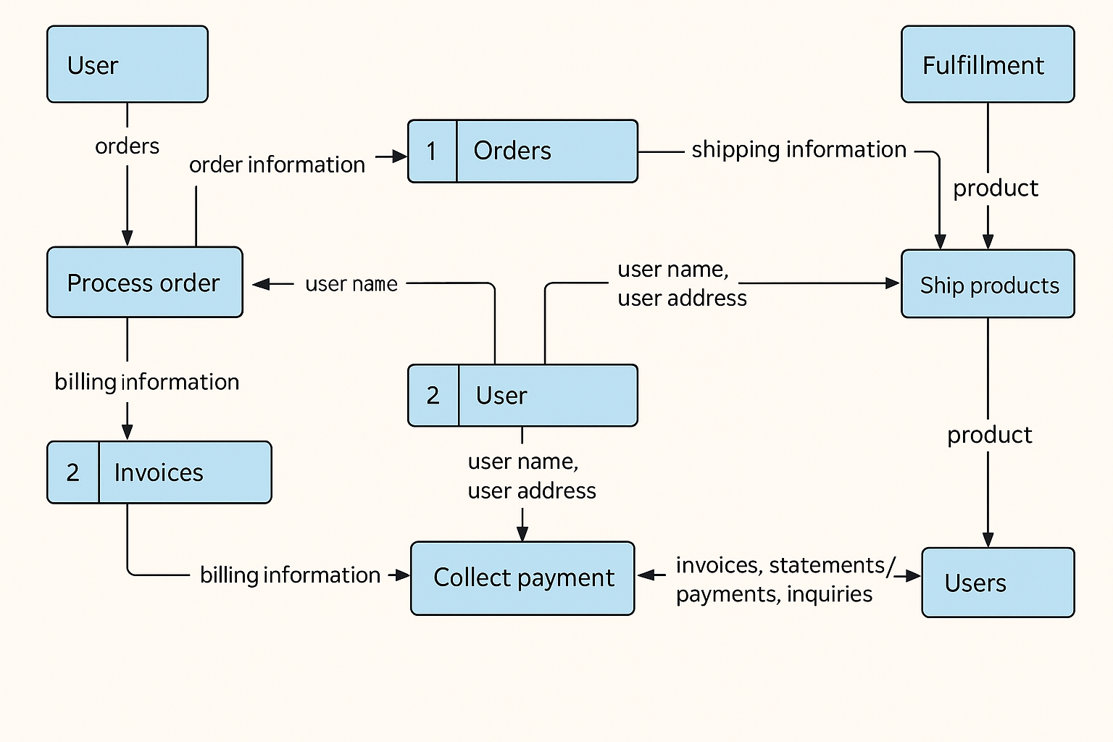

**User Stories:**

**User Type: Customer (Mobile/Web User)**

| **User Type** | **Functional Requirement (Epic)** | **User Story Number** | **User Story / Task** | **Acceptance Criteria** | **Priority** | **Release** |
| --- | --- | --- | --- | --- | --- | --- |
| **Customer (Mobile)** | Registration | USN-1 | As a user, I can register by entering my email, password, and confirming my password. | I can access my dashboard after successful registration. | High | Sprint-1 |
| **Customer (Mobile)** | Registration | USN-2 | As a user, I receive a confirmation email once I complete registration. | I can receive and click the confirmation email. | High | Sprint-1 |
| **Customer (Mobile)** | Registration | USN-3 | As a user, I can register using my Facebook account. | I can sign up and access the dashboard using Facebook login. | Low | Sprint-2 |
| **Customer (Mobile)** | Registration | USN-4 | As a user, I can register using my Gmail account. | I can register successfully with Google sign-in. | Medium | Sprint-1 |
| **Customer (Mobile)** | Login | USN-5 | As a user, I can log in using email and password. | I can log in and access the dashboard securely. | High | Sprint-1 |
| **Customer (Mobile)** | Dashboard | USN-6 | As a user, I can view personalized scheme suggestions. | I see schemes that match my age, location, and profile. | High | Sprint-2 |
| **Customer (Mobile)** | Dashboard | USN-7 | As a user, I can filter schemes by category, department, or eligibility. | Filters show accurate results based on selected inputs. | High | Sprint-2 |
| **Customer (Web)** | Dashboard | USN-8 | As a user, I can view usage analytics and interact with scheme charts. | Charts and statistics are displayed on my dashboard. | Medium | Sprint-3 |

**User Type: Customer Care Executive**

| **User Type** | **Functional Requirement (Epic)** | **User Story Number** | **User Story / Task** | **Acceptance Criteria** | **Priority** | **Release** |
| --- | --- | --- | --- | --- | --- | --- |
| **Customer Care Executive** | Admin Tools | USN-9 | As a care executive, I can view and respond to user queries in real time. | I can see open queries and send responses to users. | High | Sprint-3 |

**User Type: Administrator**

| **User Type** | **Functional Requirement (Epic)** | **User Story Number** | **User Story / Task** | **Acceptance Criteria** | **Priority** | **Release** |
| --- | --- | --- | --- | --- | --- | --- |
| **Administrator** | Analytics | USN-10 | As an admin, I can view usage metrics, user count, and scheme interaction trends. | Real-time reports are visible for analysis. | High | Sprint-4 |
| **Administrator** | User Management | USN-11 | As an admin, I can manage user accounts, deactivate users, or reset passwords. | I can edit user accounts and see updates reflected live. | Medium | Sprint-4 |